**Web Phishing Detection**

**Testing Model**

|  |  |
| --- | --- |
| Date | 15 November 2022 |
| Team ID | PNT2022TMID42479 |
| Project Name | Project – Web Phishing Detection |
| Maximum Marks | - |

**Executing the model:**

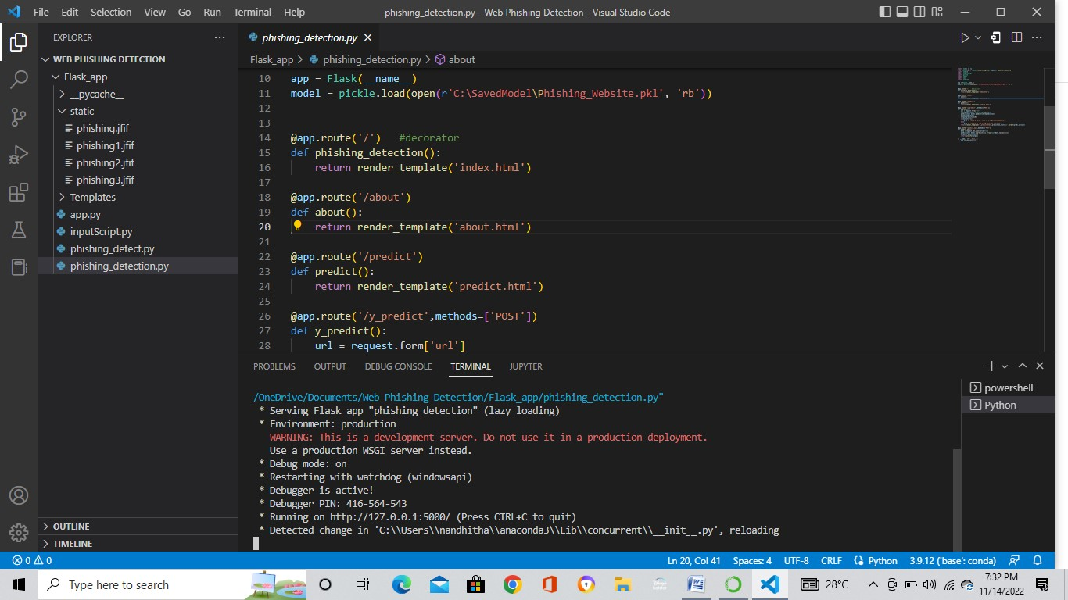

**Home page of the web application:**

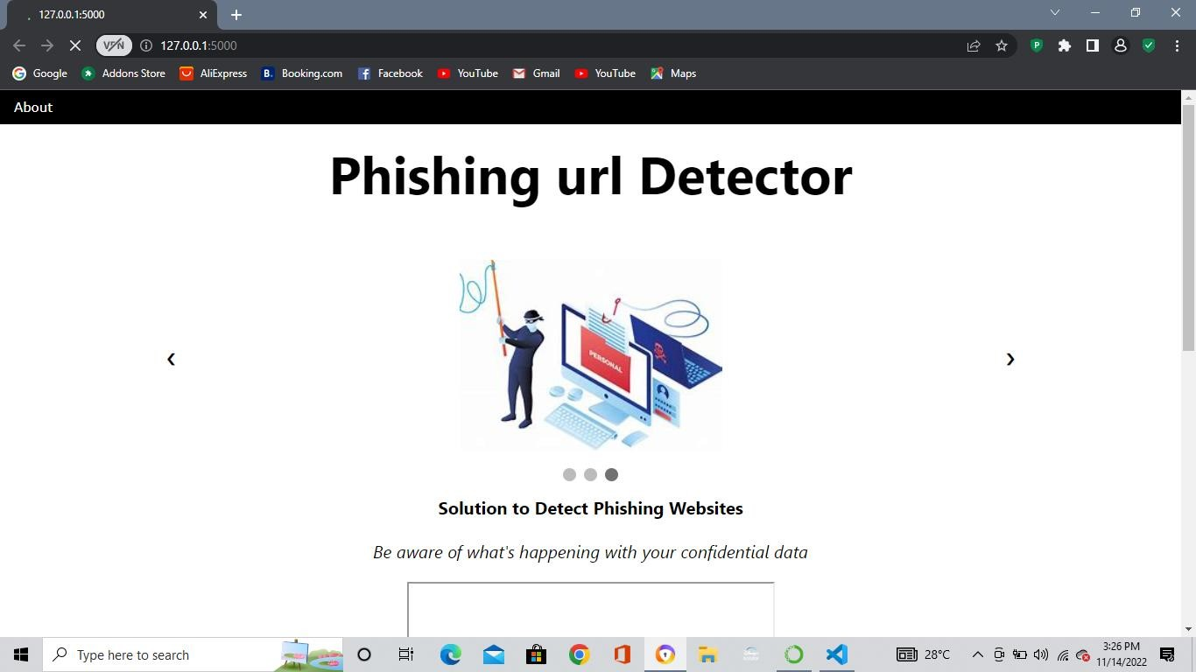

**About page:**

The user upon clicking the about button available in the navigation bar, the user will be redirected to the About page.

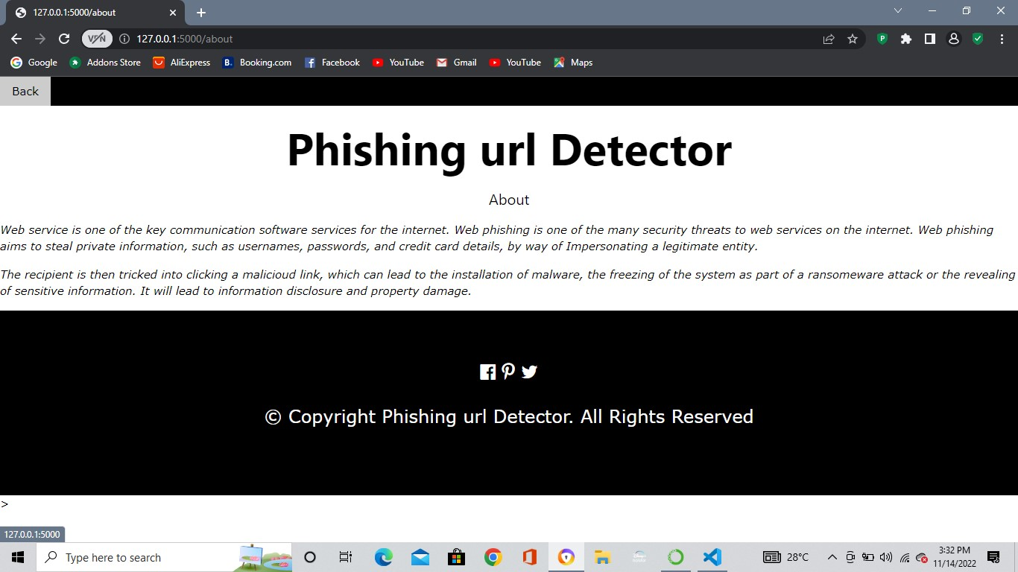

**Prediction page:**

* Now when the user clicks on the “Click here to get started” link, the user will now be redirected to the prediction page.
* In the prediction page the user can enter the url in the search bar, and when he clicks on the “Predict” button the user will be redirected to the y_prediction page.

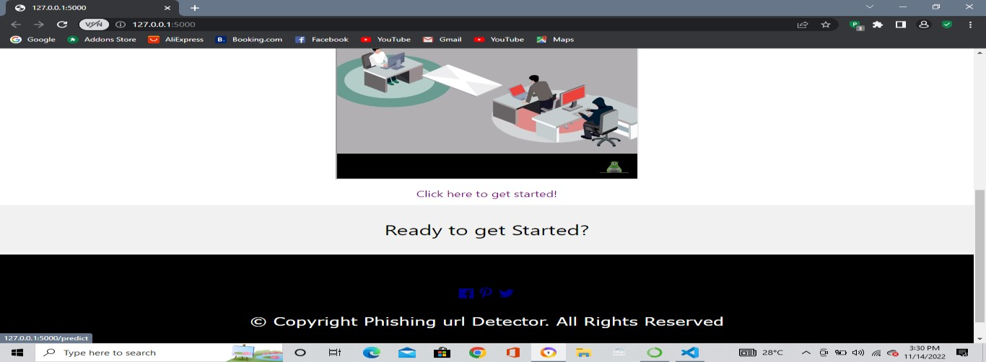

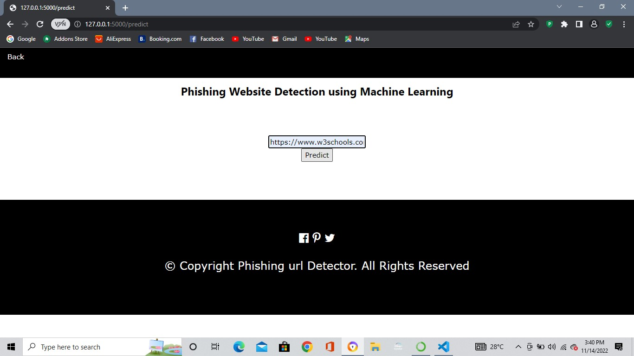

**Y_prediction page:**

Now in this page the output is displayed. If the url is legitimate then the message is displayed stating that “You are safe!! This is a Legitimate Website.” else if the url is a phishing url then the message is displayed as “You are on the wrong site, Be cautious!”.

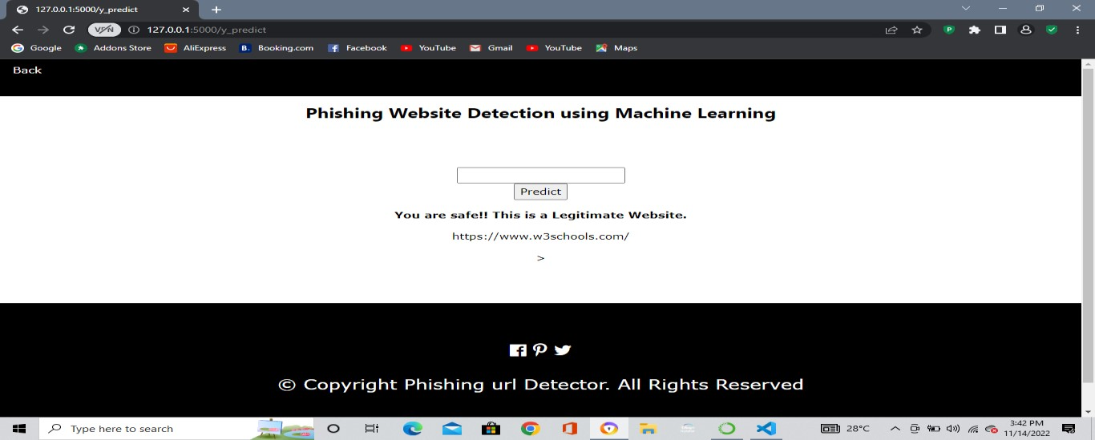

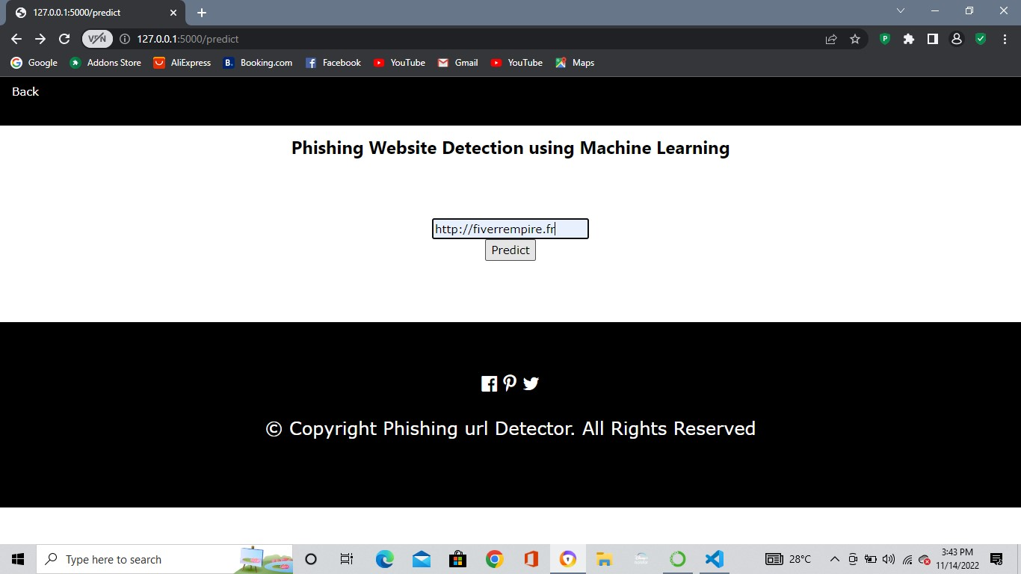

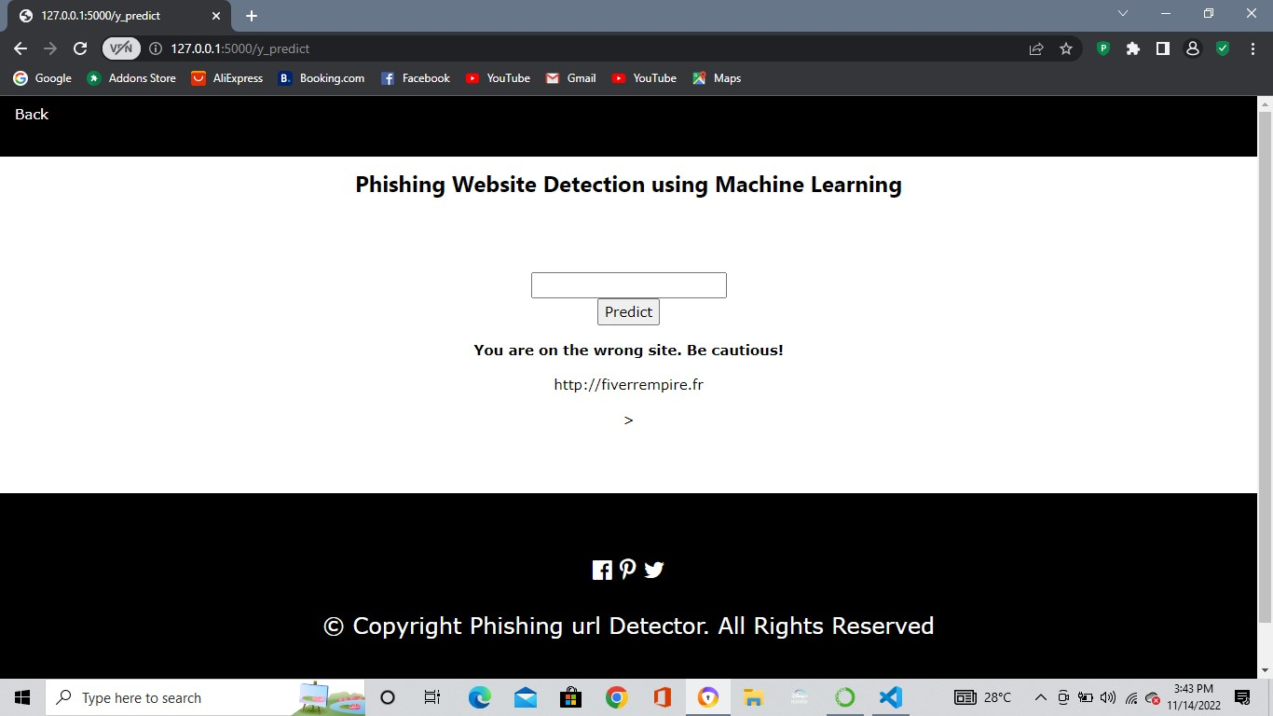

**Conclusion:**

We have successfully built the model for predicting the phishing urls and have successfully built the web application using flask framework and the testing is done and the website works successfully as expected. We have used the Random Forest Classifier since it has produced 96.56% accuracy for producing accurate result.